A73-AM,S- Peru-Mochica-Diadem-Condor Head and Wings, and Octopus Tentacles-100-800 AD-CE

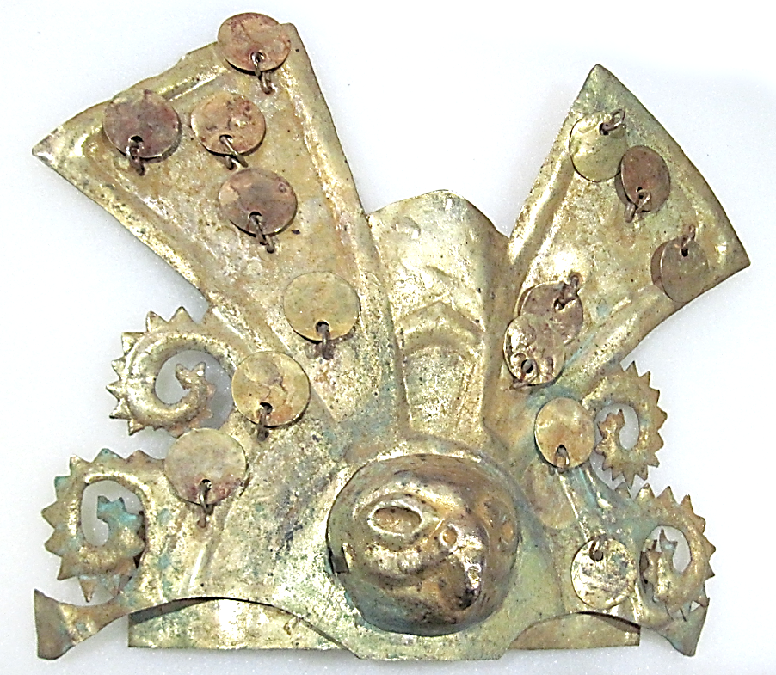 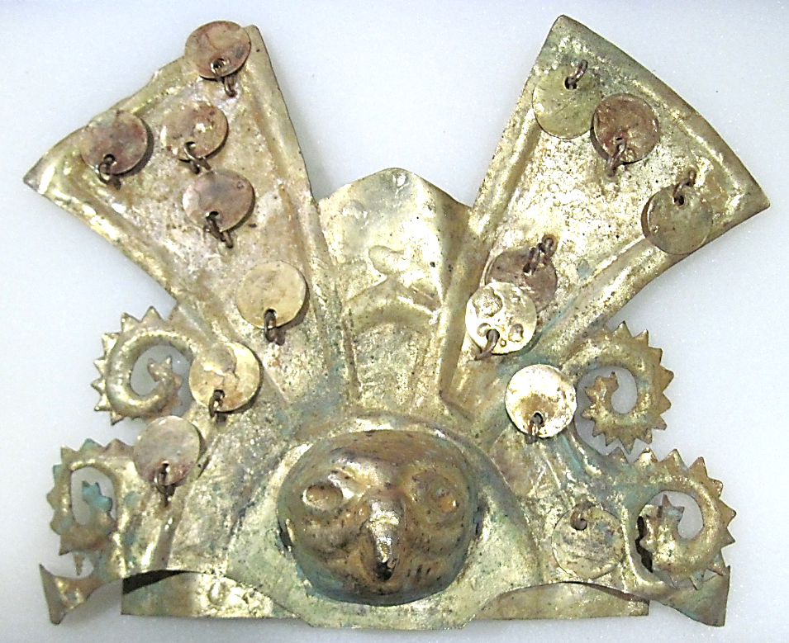

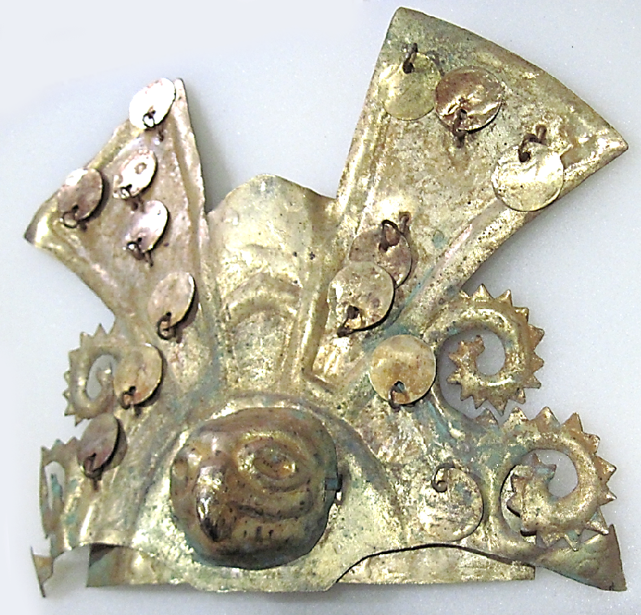 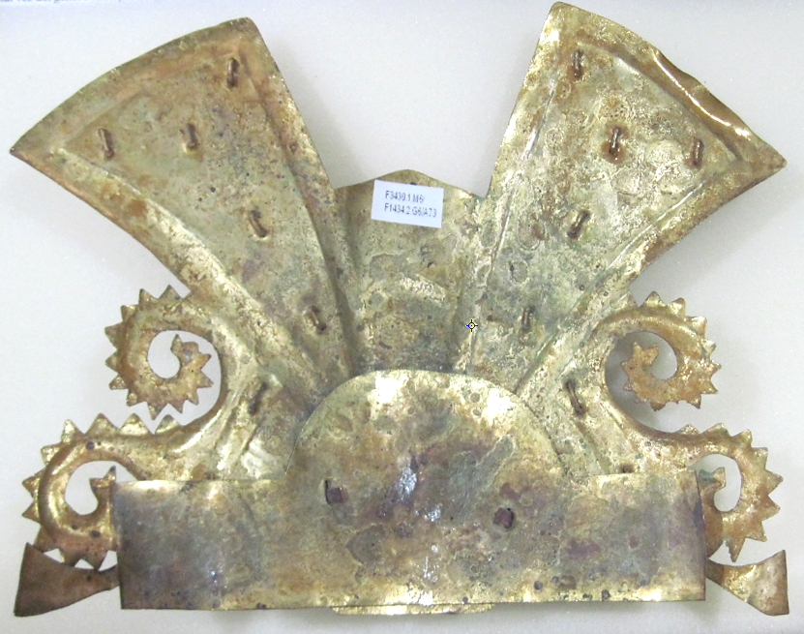

Figs. 1-4. Peru-Mochica-Diadem-Condor Head and Wings, and Octopus Tentacles-100-800 AD/CE

**Case no.:7**

**Accession Number: A73**

**Formal Label:** Peru-Mochica-Diadem-Condor Head and Wings, and Octopus Tentacles-100-800 AD/CE

**Display Description:** The Mochica, 100-800 AD/CE, (who spoke a Chimuan language until the 1920’s when it died out) inhabited an area of NW coastal Peru, bordered by the Pacific in the west and the Andes in the east. The sea and the mountains are symbolized in this diadem of eight octopus tentacles emanating from the body of a condor whose outstretched wings tower above the diadem as the pinnacle of Andean birds. However identifiable these creatures are, their true meaning rests in their metaphoric significance as octopus and condor deities of the deep sea and the high mountains. The octopus was regarded as the most tenacious of the cephalopods of Peru by the Mochica. They admired its ability to survive the cold Humboldt Current that surges from the Antarctic past NW Peru with its rich harvest of plankton and fish that provides the local near-shore denizens (seals, sea-lions, crabs, lobsters, catfish and octopus) with ample food that the Mochica fished from their small, precarious totora reed rafts, probably like the modern caballitos. The condor was regarded as the most ominous predatory bird of the Andes.

**LC Classification:**  F3430.1

**Date or Time Horizon:** 100-800 AD/CE

**Geographical Area:** NW Peru, coast

**Map, GPS coordinates:** 8°01'S, 79°W, -8.02, -79.00

**Cultural Affiliation:** Mochica

**Media:** Gold

**Dimensions:** W 196.51 mm

**Weight:**

**Condition: original.**

**Provenance:** local Peruvian collection, 1960’s.

**Discussion:**

Other versions of the Mochica octopus deity are:

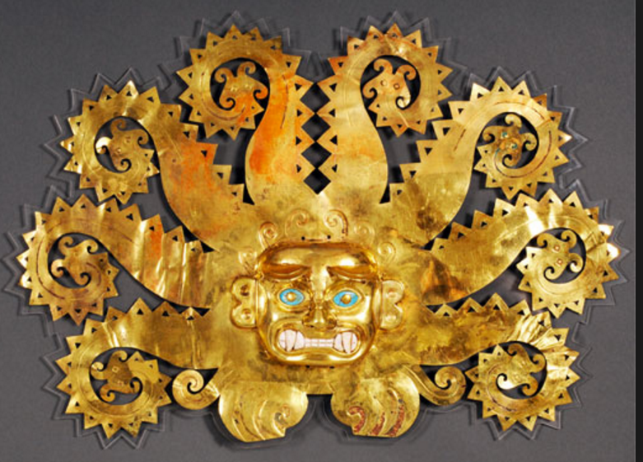

Mochica, 100-800 AD/CE, perhaps from La Mina. Octopus-Anthropomorphic Jaguar deity. Octopus tentacles ending in catfish heads, central boss of anthropomorphic jaguar deity. Gold, chrysocolla and shell. L 41.4cm, H 28.5 cm. Museo de Nacional, Lima. <https://www.herodote.net/_images/perou-mochica.jpg>

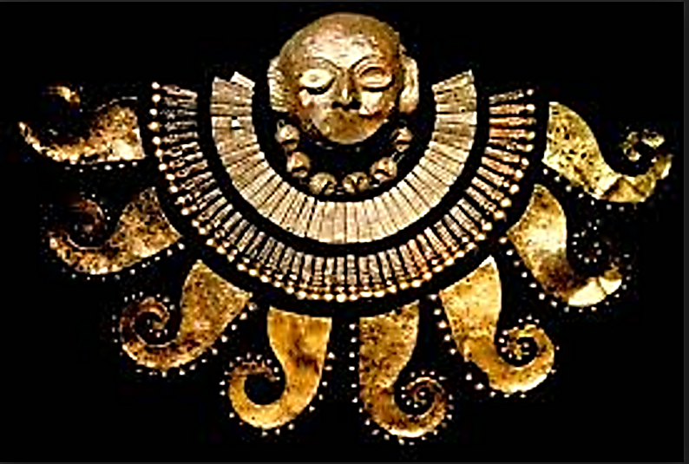

Mochica 100-800 AD/CE, NW coastal Peru perhaps from La Mina. Mortuary anthropomorphic mask with octopus tentacle breastwork.

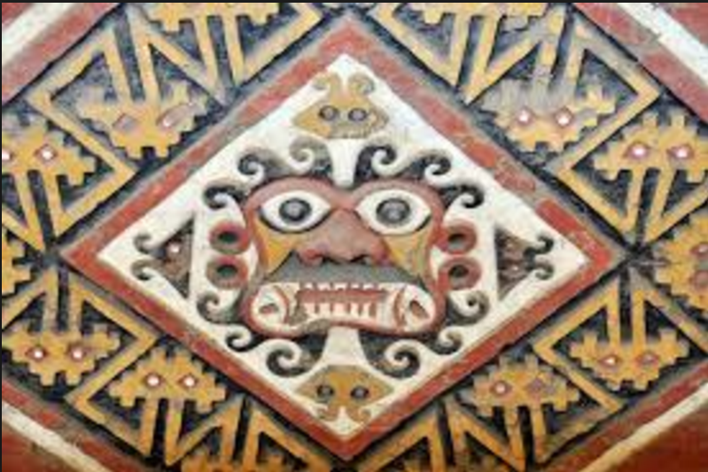

Mochica, 100-800 AD/CE, Octopus-Jaguar shaman deity, perhaps [Aï -Apaec](https://www.google.com/url?sa=i&rct=j&q=&esrc=s&source=images&cd=&ved=&url=https%3A%2F%2Fes.pinterest.com%2Fpin%2F410883165982412162%2F&psig=AFQjCNH-ixIUJKzpGE04CLpb89B3BoFG0A&ust=1504453523171372). Central figure is surrounded by catfish. NW coastal Peru perhaps from La Mina. From https://www. pinterest.com%2Fpin%2F410883165982412162%2F&psig=AFQjCNH-ixIUJKzpGE04CLpb89B3BoFG0A&ust=1504453523171372

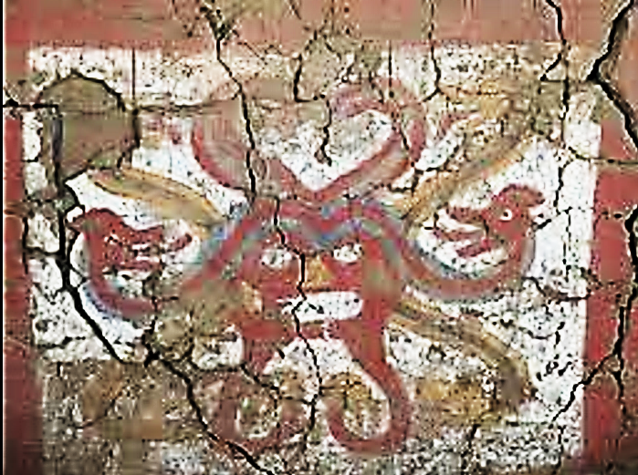

[Tripfreakz.com](https://www.google.com/url?sa=i&rct=j&q=&esrc=s&source=images&cd=&ved=&url=http%3A%2F%2Ftripfreakz.com%2Foffthebeatenpath%2Fmoche-sun-and-moon-pyramids-demonic-snails-and-decapitators&psig=AFQjCNH-ixIUJKzpGE04CLpb89B3BoFG0A&ust=1504453523171372)

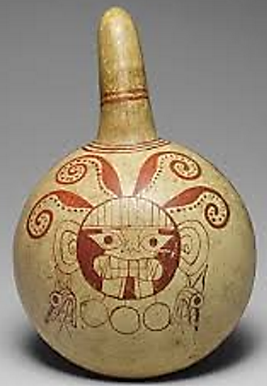

Mochica ceramic dipper, 100-800 AD/CE, possibly La Mina, NW coastal Peru. Octopus and Jaguar/Sun deity. Cream glaze with red painting of four octopus tentacles and circular jaguar/Sun deity, with two mythic-animal earrings and three circular pendants. Heilbrunn Timeline of Art (64.228.15). See Benson 1972: 31, fig. 2-5.

**References:**

[*Adelaar, Willem F. H.*](https://en.wikipedia.org/wiki/Willem_Adelaar) (1999). "Unprotected languages, the silent death of the languages in Northern Peru". In Herzfeld, Anita; Lastra, Yolanda. The social causes of the disappearance and maintenance of languages in the nations of America: papers presented at the [*49th International Congress of Americanists*](https://en.wikipedia.org/wiki/International_Congress_of_Americanists), Quito, Ecuador, July 7–11, 1997. Hermosillo: USON.

Benson, Elizabeth. 1972. The Mochica. NY: Praeger.

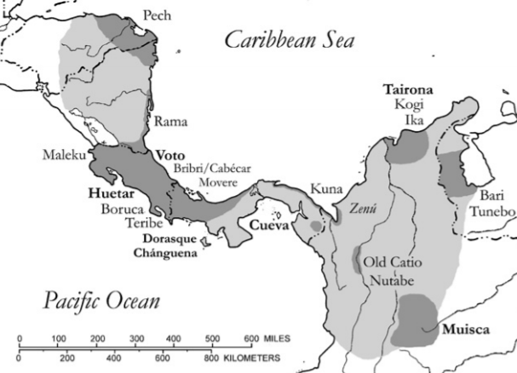

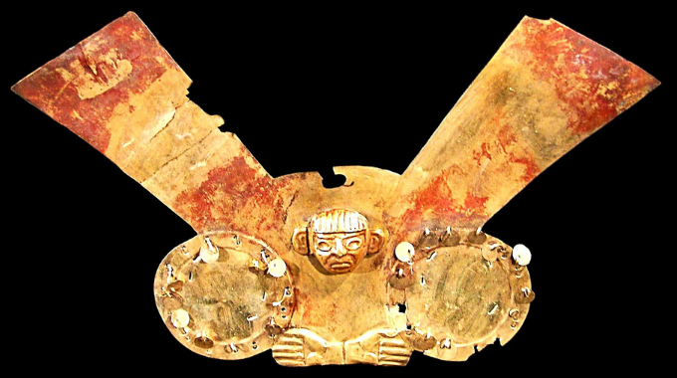

**mochica**  **Museo Oro del Perú – Lima**

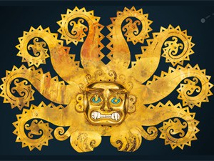

Mochica, North Coast Peru, possibly La Mina. Diadem with feline head and octopus tentacles ending in catfish heads (100 – 800 A.D.), Gold, chrysocolla, and shells. 28.5 x 41.4 x 4.5 cm